CORRECTED FOURTH REPORT OF THE COURT MONITOR
ON PROGRESS TOWARD COMPLIANCE

WITH THE AGREEMENT:

U.S. v. STATE OF DELAWARE

U.S. District Court for the District of Delaware, Civil Action No: 11-591-LPS

September 24, 2013
(Originally filed September 16, 2013)

I. Introduction
This is the fourth report of the Court Monitor (“Monitor”) on the implementation of the above-referenced Settlement Agreement (“Agreement”) between the United States, through the U.S. Department of Justice (“DOJ”), and the State of Delaware (“the State”). This report covers the six-month period January 15, 2013 through July 15, 2013 and it reflects the State’s two full years of progress.
Whereas the last report covered a period in which the Agreement specified only one new requirement (relating to Intensive Care Management), the current report coincides with requirements relating to numerous new benchmarks that cover a range of program areas. As is detailed below, Delaware has met—and often surpassed—each of the targets scheduled to be achieved in this review period.
Furthermore, the State is making progress in addressing what might be called structural issues, factors that cut across specific provisions, but that have been cited in prior reports by the Monitor as being critical to achieving the immediate and long-term requirements of the Agreement. These structural issues include the use of data, the reliance on court-ordered treatment, and the State’s complex arrangements for the management of inpatient and outpatient services.
Because each of these issues has implications for multiple measures of compliance with the Agreement, this report begins with a discussion of progress in these structural areas, followed by an evaluation of compliance with specific provisions of the Agreement. In several instances, explanations of the State’s compliance with individual requirements of the Agreement refer back to the broader measures the State is taking to address underlying structural issues.

II. Progress on Structural Improvements

- Use of Data
In keeping with recommendations in the Monitor’s past reports, the State has been working to improve its capacities for capturing good data and using this information to monitor service quality and guide decision making. This is happening on two tracks. While Delaware is proceeding with a program of broad, long-term upgrades to its information technology (“IT”) systems, it is also moving forward on some more immediate, and much-needed, expansions of capacities within DSAMH that are essential to its meeting the requirements of the Agreement. These short-term measures are still incomplete, but they are already offering a glimpse of how a fully functional information system can vastly increase the State's abilities to monitor the quality, impact and efficiency of DSAMH's services to individuals with SPMI. As an example, four new IT positions are being requested by DSAMH. These will address a critical need for data analytics that are specifically tailored to people with SPMI and the multiple systems that serve them. Further progress is being made with the imminent adoption of electronic medical records at Delaware Psychiatric Center (“DPC”); this should vastly improve access to clinical information and related quality assurance.
As has been noted in previous reports, in many respects DSAMH has been accustomed to functioning in the absence of timely and reliable data, and this has hampered its abilities to maximize outcomes and efficiencies. During the past six months, the Monitor has been working very closely with leadership in the Division to systematically incorporate data in its tracking of compliance with the Settlement Agreement. DSAMH has created a “dashboard” that reflects its current status with regard to each of the Settlement’s key elements and that supplies data essential to compliance monitoring (both internally and by the Monitor). In addition, it has begun to produce trending data relating to these elements and other performance indicators.
The State’s significant progress in this area since the last report is evidenced throughout this report, which incorporates several of the trending charts that are beginning to be used on an routine basis to evaluate services and their impact. Again, while acknowledging the State’s significant advances during the last six months, the data set reflected in this report should properly be regarded as a work in progress.

Targeted Priority Population List:
One early challenge confronting the State with respect to data concerned the establishment of a Targeted Priority Population List (“TPPL”), in keeping with Section II.B of the Agreement. The construction and maintenance of this list have required the State to integrate disparate data across departmental divisions, among them mental health, corrections, Medicaid and housing. This has been an enormous, but worthwhile undertaking. While the TPPL continues to be refined over time, it provides an increasingly clear picture of the population with Serious and Persistent Mental Illness (SPMI) that is served by Delaware’s public systems. This information—much of which was simply nonexistent in a usable format when the Agreement was formulated—now provides essential information about strategies for compliance and for future planning.
The TPPL currently includes 8,254 individuals, whose historical or current characteristics are as follows (an individual may be represented in more than one category):
- Treatment at DPC 8.25%
- Treatment in an IMD 53.76%
- Criminal justice contact 31.11%
- Homeless 27.67%
- Emergency room use for mental health 25.64%
These data not only show the levels of clinical and social disability of the targeted population, but also the impact that improved outcomes (such as those that are being realized through implementation of the Agreement) can have on multiple State systems.

Evaluation of Individuals Discharged From DPC Following Long Hospitalizations:
DSAMH is beginning to apply its improving data capacities to generate studies that focus on specific service issues. A recently completed evaluation in collaboration with the Monitor demonstrates the Division’s growing ability to evaluate the impact of new programs created in accordance with the Agreement, as well as changes it is making in practices to reduce its reliance on court-ordered treatment. A summary of this evaluation and its important findings is presented below.
Description of the Population-
The evaluation focused on a high-risk, high-expense population of individuals who were discharged from DPC between July 1, 2012 and June 30, 2013, following at least 60 days of continuous inpatient care. The 105 individuals who met these criteria have extensive inpatient histories, averaging 1147.1 days (about 3 years) at DPC, with a median length of stay of 140 days (about 4.6 months). Some of the individuals who were discharged into more integrated community settings had been at DPC since the 1960s.
The community services to which these individuals were referred were as follows:
- 72 of these individuals (68.6%) were referred to the high-end community services created pursuant to the Settlement: Assertive Community Treatment (ACT), Intensive Care Management (ICM), or the Community Reintegration Support Program (CRISP).
- 11 (10.5%) received Targeted Care Management (TCM) that was created pursuant to the Settlement.
- The remaining individuals were referred to state-operated community clinics or other programs.
The living arrangements to which the vast majority of these individuals were referred—80.9%—affirm that, even for this high-need population, integrated community living is a viable option. The specific breakdown of were living arrangements is follows:
- 23 individuals (21.9%) received SRAP vouchers to enable them to live in scattered-site supported housing.
- 38 (36.2%) received needed housing supports (in scattered-sites, unless otherwise approved following DSAMH’s review process) through the CRISP program.
- 24 (22.8%) returned to their family homes with needed supports.
- 3 (2.9%) were referred to group homes.
- The remaining 17 individuals (16.2%), following DSAMH’s review process, went to other settings consistent with their needs.
The information presented above demonstrates the State’s effectiveness in moving from an institutional model of services to far more integrated settings.
This group’s level of need is not only reflected in its protracted stays at DPC—together, members of the group consumed 120,447 hospital days during their last admissions—but they also have very significant functional deficits. The Global Assessment of Functioning scale (GAF) is a measure from 0 to 100 that is commonly used in mental health to assess an individual’s status. At the point of their discharge from DPC, the average GAF for this group was 28.1, which indicates:
Behavior is considerably influenced by delusions or hallucinations OR serious impairment in communication or judgment (e.g., sometimes incoherent, acts grossly inappropriately, suicidal preoccupation) OR inability to function in almost all areas (e.g., stays in bed all day; no job, home, or friends).

Legal Status-
As is discussed in the next section, the State has been making significant efforts to move away from court-ordered treatment (both inpatient and outpatient) and towards a system that is much more oriented towards voluntary services. During the period covered by this study, DSAMH took some important measures to reduce referrals for outpatient commitment, and rates of these court orders have declined accordingly. Given the histories of most of the individuals included in this study (multiple hospitalizations, criminal justice involvement, emergency room use, very significant levels of disability and so on), this is the population that is often considered as appropriate for court supervision following discharge.
The study had some surprising (and positive) findings in terms of how individuals fared with or without court-ordered treatment. Of the 105 individuals, 26 (24.8%) were discharged with a continuing order for outpatient commitment; 79 (75.2%) were not under a court order. The mean GAF score for individuals who were discharged on outpatient commitment 26.8 and the median was 25. The mean GAF score for individuals who were discharged without a court order was 28.6, with a median of 30. For both groups, the similarity of the mean and the median suggests a normal (“bell-shaped”) distribution that is not skewed by outlier GAF scores.

Further analysis of these data yielded an important finding; contrary to what one might have expected, the group of individuals who were outpatient committed was not more impaired than the group with no court order. In other words, both groups comprise individuals with severe functional disabilities, and the GAF scores of those with court-ordered treatment in the community were not significantly different from those who were not subject to continuing court supervision. Accordingly, whether there were differences in how these individuals fared in the community can be helpful to the State as it continues to roll out processes aimed at increasing voluntary services and as it studies potential changes in its mental health laws.

Readmission Rates-
The chart below presents the 30- and 180-day readmission rates of these 105 individuals who were discharged in the past year, following 60 days or more of continuous inpatient care at DPC. For comparison are the most recently published national readmission rates and those for the state of Delaware.
 | 30-DAY READMISSION RATE | 180-DAY READMISSION RATE
Post-Discharge DPC Population of 105 Individuals:
Readmission Rates | 4.7% | 13.2%
Comparison Rates:
U.S. Rates (SAMHSA, 2011) | 9.3% | 21.0%
Delaware Rates (2013) | 9.6% | 23.1%

Fourteen (14) members of this group (13.2%) were re-hospitalized within 180 days of their discharge from DPC, 5 of whom (4.7%) were readmitted within thirty days. Notwithstanding the histories and functional levels of these individuals that place these individuals at very high risk of failure in the community, these readmission rates are at least 45% lower than the national rates for 180-day and 30-day readmissions (21.0% and 9.3%, respectively) and the Delaware’s overall psychiatric readmission rates (which are very consistent with these national norms). Most importantly, These significant findings highlight that, even for this at-risk group, the intensive services and integrated housing opportunities that the State has created pursuant to the Settlement Agreement are being successful in maintaining people with serious and persistent mental illnesses within the community. In fact, these individuals actually have lower rates of psychiatric rehospitalization than does the general population of individuals with serious mental illness.

Fiscal Impact-
It is worth noting that, based on an estimated cost of care within DPC of $800 per day, the median length of stay of 140 days would mean hospital costs of about $112,000 per person. Applying the average length of stay of this group of 1,147.1 days, a rough estimate of the cost incurred for their hospital care is a remarkable $917,680 per person. A meaningful cost estimate would be somewhere between these figures but, no doubt, would be substantial.
In any event, given that care within DPC is generally not reimbursable through Medicaid or other insurance, these costs have largely been borne by the state of Delaware. In contrast, many of the services being provided to these individuals within the community are not only lower cost, but they draw in federal dollars through Medicaid or other programs. The average annual total cost of supporting an individual in the community with Assertive Community Treatment (ACT) services is $23,500 ($15,000 for ACT services + $8,500 for SRAP housing supports). Taking into account that ACT services are reimbursable through Medicaid and draw federal dollars, the costs to the State are even lower, approximately $16,000 ($7,500 state Medicaid match for ACT + $8,500 for SRAP housing supports). In other words, applying the more conservative median cost of hospitalization at DPC of $112,000 per person, the community supports to these individuals pursuant to the Agreement represent savings to the state of about 86%. The table below summarizes annualized projections (since the mean length of stay for this group was greater than one year, full year costs are presented instead):

Cost Comparison of Evaluation Group:
DPC vs. Intensive Community Services
 | Annual Cost Basis | Total Annual Cost |  | Federal Medicaid | Net State Cost
DPC | Hospital Days: | Median  140 | Full Year  365 |  | Median 140 | Full Year  365
 | Inpatient care @$800 | $112,000 | $292,000 | $0 | $112,000 | $292,000
Community | ACT @$15,000 +  SRAP Housing @$8,500 | $23,500 |  | $7,500 | $16,000
Range of Annual Savings/Person: |  | $88,500 to $268,500 |  |  | $96,000 to $276,000

Readmissions and Legal Status-
Finally, this evaluation yielded some very interesting information regarding outpatient commitment and its impact. Generally, proponents of outpatient commitment assert that for people with serious mental illness and significant impairments—both of which characterize this group—court intervention improves outcomes and results in fewer hospitalizations. In contrast to outpatient commitment programs in some other states, in Delaware outpatient commitment does not entitle individuals to an enhanced package of services, nor does it improve one’s access to services.
All of the individuals in this group had access to services in accordance with their discharge plans and needs, and their post-discharge legal status presented neither an advantage nor a disadvantage in receiving these services. For example, as referenced above, 24.8% of the group was discharged on outpatient commitment status, but 68.6% received high-end services such as ACT. The individuals who were outpatient committed received the same level of service and access to housing as those who were not. That being said, and considering that the functional status of these two groups was essentially the same, it was interesting to find that individuals who were outpatient committed were much more—not less—likely to be re-hospitalized than those who were receiving community services voluntarily.
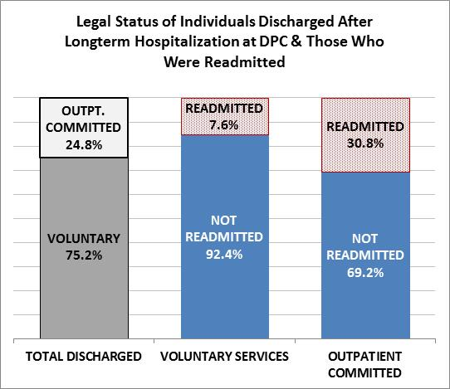
The chart below summarizes the striking differences between these groups. Of the 79 individuals who were discharged without an outpatient commitment order, only 6 (7.6%) were readmitted. Individuals who had outpatient commitment orders were about four times more likely to be readmitted than were those who were receiving the same services voluntarily.

Recommendations:
This evaluation demonstrates movement within DSAMH towards much more data-driven oversight of services and their impact, as well as the potential for information technology to inform planning and policy decisions. As evidenced by this evaluation and data presented throughout this report, the State has made palpable progress in this area. Nevertheless, the data presented here are best regarded as a preview. DSAMH remains significantly limited in its abilities to produce and appropriately analyze data in ways that will maximize its performance. It is important that it quickly move forward on its plans to expand its IT capacities with individuals who are versed in data analysis, as well as the array of services and systems affecting the population covered by this Agreement.

- Reliance on Court-Ordered Treatment
Prior reports by the Monitor have discussed a long tradition in the State’s mental health system of relying on court-ordered inpatient and outpatient treatment. In some instances, involuntary treatment was occurring in the absence of clear clinical or legal bases. Furthermore, the policy of DSAMH underwriting the cost of inpatient care in a private psychiatric hospital (“IMD”) only when under court order created the unintended incentive of encouraging involuntary admissions to ensure payment.
Judicial involvement in mental healthcare should be a last-resort, emergency measure. When it becomes necessary to turn to the courts, an assessment should be triggered to determine how earlier-on voluntary services might have averted the involvement coercive treatment. Unwarranted involuntary treatment—including court-ordered treatment to reduce providers’ perceived liability, assure payment, or as a substitute for good consumer engagement—is not the “least-restrictive” approach consistent individuals’ rights under the ADA and other state and federal laws. Furthermore, absent a specific and carefully considered individual need, coerced treatment is inconsistent with the recovery orientation that DSAMH is pursuing system wide.
The State continues to take significant steps to move to a much more voluntary system of services. On a case-by-case basis, DSAMH will now reimburse IMDs for the cost of needed inpatient care in the absence of a court order. Further, both the Division and representatives of the State Attorney General’s office have been working with providers and the courts to ensure that orders relating to outpatient commitment are based on specific, well justified, and demonstrably least-restrictive requests, with clarity as to what is required of the individual to demonstrate compliance.
The chart below presents the State’s continuing, dramatic progress in reducing its reliance on court-ordered treatment for both inpatient and outpatient services. The chart shows the number of individuals who were under active civil commitment orders each month by type of order, as well as the monthly average for the year prior to implementation of the Agreement (i.e., June 15, 2010-July 15, 2011). Overall it shows about a 34% decrease in both inpatient and outpatient commitments relative to that base year.
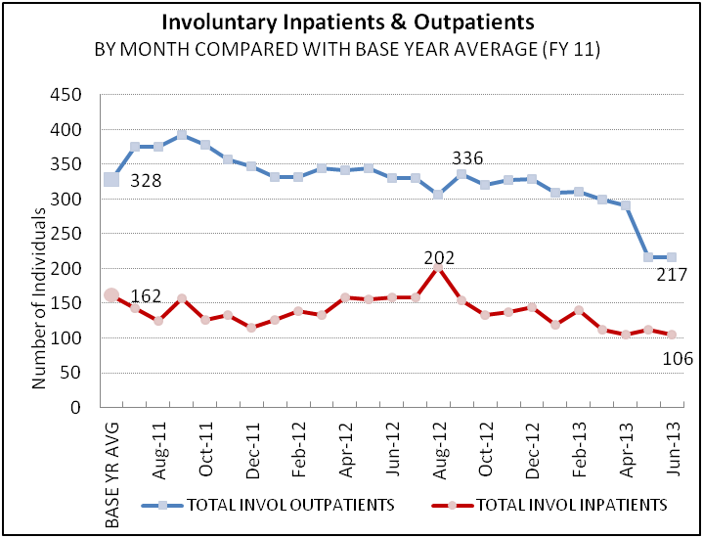
These trend data not only allow the State to evaluate its progress, but also are informative about the impact of its interventions. For example, revisions in the Delaware’s law with respect to outpatient commitment are currently under discussion by a legislatively mandated study group and the State is about to issue new guidance with more specific requirements for how providers may petition for outpatient commitment. Neither of these efforts was completed at the time the above chart was generated. Yet, the graph shows a dramatic decrease between February and May of 2013—about 27% —in the number of people with outpatient commitments. These occurred as DSAMH began apprising stakeholders of the impending changes in the process for seeking outpatient commitments.
It is reasonable to expect that Delaware will continue its trajectory of reducing its reliance on court ordered services, particularly as the planned procedural changes in the outpatient commitment process go into effect, the impact of crisis and diversion services (discussed below) continues to expand, and further refinements are made in the legal and policy framework in which services are delivered. As is evidenced in the data presented in this and the prior sections, DSAMH is rapidly expanding its capacities to capture and analyze data relating to the reliance on court-ordered treatment and how individuals are faring in a system more oriented towards voluntary services.

- Management of Clinical Services
Past Monitor reports have called attention to the State’s overly complex systems for managing the care of individuals receiving public mental health services. Essentially, depending upon an individual’s status with regard to Medicaid, during the course of a year an individual’s care may be overseen by DSAMH; or the Division of Medicaid and Medical Assistance (“DMMA”), via a managed care organization (“MCO”); or a combination of the two. This arrangement has built-in inefficiencies and inconsistencies in addressing the needs of people with serious and persistent mental illness.
Matters are further complicated as the Affordable Care Act comes into effect, as many individuals with SPMI who have heretofore been supported with State dollars through DSAMH will be newly eligible for Medicaid or have access to insurance via the marketplace. Furthermore, the State is pursuing changes in its Medicaid plan which will expand coverage for services such as supported employment and care management. In all instances, it is important that individuals be afforded appropriate access to services and monitoring to ensure that these services are necessary and having their intended benefits.
Each of the Monitor’s prior reports has discussed how the current care management arrangement, with its shifting responsibilities, is problematic. This is particularly the case with respect to the State’s obligations under the Agreement to reduce its psychiatric inpatient bed-days (See discussion of Crisis Stabilization Services below). Notwithstanding the Monitor’s prior recommendations, the State’s disjointed arrangements for managing inpatient and other services to individuals with SPMI persist to this day, and the State still does not have a specific plan to improve this critical oversight function.
The discussion of Crisis Stabilization Services includes a chart entitled “Inpatient Days by Provider Type by Month.” This chart shows that, over time, DPC is accounting for a significantly decreasing proportion of inpatient bed-days, that bed-day use in the IMDs has been fairly constant when managed by DSAMH, and that it is trending upward when managed by DMMA via the MCOs. Fulfilling the requirements of the Agreement will require not only a continuation of bed-reduction efforts at DPC, but a much more concerted approach to manage inpatient utilization within the IMDs.
- Inpatient Care Management by DSAMH
Individuals’ inpatient care in IMDs is managed by DSAMH’s Eligibility and Enrollment Unit (“EEU”) when they are uninsured, when they have been carved out for high-end services (such as Assertive Community Treatment), or when individuals who have Medicaid coverage have exhausted their benefits under the capitated managed care contracts DMMA holds with MCOs.
The EEU is not staffed to review and approve admissions before they occur. However, when an individual is admitted with DSAMH as the payor, that individual has gone through one or more gatekeepers within the mental health system (e.g., a Crisis Walk-In Center, Mobile Crisis), and a determination has been made that alternatives to inpatient care (such as Crisis Apartments) are not viable. DSAMH has recently expanded its capacity to conduct on-site Utilization Review at the IMDs. Typically, approval for inpatient care is given in 24-hour increments.
- Inpatient Care Management by DMMA
Inpatient care is managed by DMMA when an individual is Medicaid eligible and has not expended a 30-day annual inpatient benefit that is a part of the State’s capitated managed care contracts with two privately-operated MCOs.
The general premise behind such capitated MCO arrangements with states is that these organizations are allotted fixed (“capitated”) healthcare budgets based on the number of individuals insured and their needs, and that the financial incentives to contain costs and to reduce the risk of being financial liable for overspending the capitated rate will improve efficiencies. The problem with the psychiatric inpatient arrangement with the MCOs in Delaware is that these organizations are not at full risk. Instead of the MCO being liable for the full cost of an insured individual’s inpatient psychiatric care, once the Medicaid benefit is used up, DSAMH picks up any further inpatient psychiatric costs. In other words, the degree of the MCO’s risk—ostensibly a significant driver of cost-efficient care in the managed care world—is limited by the 30-day annual benefit.
As is the case with DSAMH, most inpatient care is approved after an individual has already been admitted to an IMD and reviews take place during regular weekday business hours. IMDs have up to 48 hours following admission to submit documentation to MCOs for a determination of whether hospital care is needed (although the admission has already occurred). Per DMMA, denials of admission by MCOs are estimated to occur less than 10% of the time. On average, the approval is granted for 6.4 days.
People with SPMI whose hospital admissions are managed by the MCOs may—or may not—have passed through DSAMH’s gatekeeping and diversion processes. This is particularly problematic because, MCOs’ decision making has not been well integrated with the full array of alternatives available through DSAMH (many of these alternatives, such as Crisis Apartments and Targeted Care Management, were developed pursuant to this Agreement).
Finally, it is important to note that although DMMA contracts with these private entities (similarly, DSAMH contracts with private providers for mental health services), the responsibility for fulfillment of this Agreement and the requirements of the ADA rests with the State. DMMA will need to make this a priority and to work much more closely with the MCOs to assure that Medicaid-funded services to individuals with serious mental illness are in accordance with the ADA and the Agreement.

During the past year, the Monitor has been working closely with leadership in DHSS, DSAMH and DMMA to craft a plan for services management that will further the State’s compliance with this Agreement, streamline its oversight of services and outcomes for people with serious mental illness, and ensure that public dollars are being utilized in ways that reduce costly hospitalizations. This work is ongoing and reflects collaboration across Divisions. However, two years into implementation of the Agreement, there is still no basic framework for how this critical oversight will occur.
With respect to the State’s obligations under the Agreement, a more coherent and unified process for services management has critical and very time-sensitive implications. For example, as is discussed later in this report, the Agreement includes an important requirement that inpatient bed-days be reduced by 30% in about a year. Achievement of this goal will reflect the culmination of most of the program reforms required by the Agreement (for instance, Mobile Crisis, ACT, and Crisis Apartments), but it cannot rely on those alone. It will also require careful control over hospitalizations. Care management must integrate each of these elements, and it must consider (and produce) timely and consistent data. Finally, as the Monitor has repeatedly recommended in the past, there should be a single, centralized point of accountability for management of hospital admissions, regardless of the public payor. The discussion below relating to hospital bed-day reduction further reinforces the importance of quickly moving ahead in resolving this issue.
Recommendations:
- The Monitor is actively working with DSAMH and DMMA to bring about some immediate measures to reduce acute care bed-days in the IMDs and DPC. These include expansions in on-site Utilization Review by DSAMH and plans for intensive meetings (beginning on a weekly basis) between the DHSS Secretary’s office, leadership at DMMA and the MCOs. The two divisions are now working on a work plan with timelines for implementing various immediate-term activities aimed at the achievement of the bed-day reductions required in the Agreement. A long-range plan is still lacking and needs to be developed concurrently.
Apropos of the above discussion of data systems, these actions are tied to regular statistical reports on how the State is faring in terms of meeting its bed-use requirements and how various interventions by this collaboration are furthering efforts to meet the benchmarks included in the Agreement. Not only in fulfillment of the Agreement, but because of pending changes in the State’s Medicaid plan and the new Medicaid expansions under the Affordable Care Act, it is very strongly recommended that the parties aggressively move to craft an immediate and longer-range management strategy.
- Regardless of payor, the State’s arrangements for managing services to individuals with serious mental illness need to improve, unifying oversight of inpatient utilization and ensuring that individuals at risk of hospital admission are appropriately evaluated for less restrictive, less expensive alternatives. What is urgently needed is a single point of accountability.
- The clinical criteria applied to determine the need for inpatient psychiatric care and whether less intrusive alternatives are appropriate should be the same, whether DMMA or DSAMH is paying for the cost of hospitalization.
- Because it is much harder to implement alternatives to unnecessary hospital care—and much more disruptive for the individual—when these determinations are made after an admission has taken place, DHSS, DSAMH and DMMA should assure that certification of the need for admission occurs prior to an individual’s transfer to an IMD. Pre-certification reviews should not be limited to regular business hours, but should be available on a 7-day/24-hour basis, as needed.
- Continuing stay reviews for individuals deemed in need of hospital care should take place on weekends, as well as during the work week. This is particularly critical for individuals with SPMI who may be hospitalized on an involuntary basis.
- The Monitor supports DMMA’s plan to significantly intensify its oversight of the MCOs with respect to the achievement of all relevant requirements of the Agreement.
- DMMA and DSAMH should immediately establish mechanisms for sharing and consolidating timely information about inpatient utilization, unmet needs in the community, and other key benchmarks of compliance with this Agreement. Status reports should be provided to the Monitor at least on a monthly basis.

III. Ratings of Compliance with the Agreement
The three structural issues discussed in the previous section have very important implications for all of the programs required through the specific provisions of the Agreement, which are discussed below. Appropriate monitoring of the utilization and impact of these programs requires a workable system of care management that is guided by complete and meaningful data. Furthermore, the ubiquitous goal of providing services that are recovery-oriented requires that they be provided on a voluntary basis, and that coercive court-ordered services occur only as a last resort.
At this juncture, the State is in Substantial Compliance with each of the benchmarks of the Agreement that are now required. In order to sustain its current success, it is essential for the State to continue progress with respect to these structural matters.

- Mobile Crisis Services

Substantial Compliance.
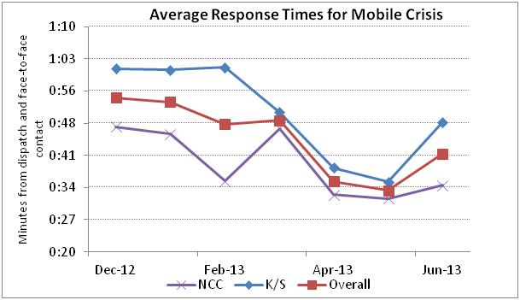
Section III.B.2 requires the State to train state and local law enforcement personnel about the availability, purpose, and procedure for accessing mobile crisis teams. The State is in compliance with this provision; it has an ongoing program of training and consultation with law enforcement personnel across Delaware.
Furthermore, as required in Section III.B.1, the State is continuing to meet the requirement of a one-hour response time to mobile crisis calls. The chart above demonstrates DSAMH’s monthly monitoring of this provision for the teams stationed in New Castle County and Kent/Sussex Counties.

- Crisis Walk-in Centers

Substantial Compliance.
Section III.C.2 of the Agreement requires the State to train all state and local law enforcement personnel about the availability and purpose of the crisis walk-in centers and the protocol for referring and transferring individuals to walk-in centers. The State is providing ongoing training to state and local law enforcement in this regard.
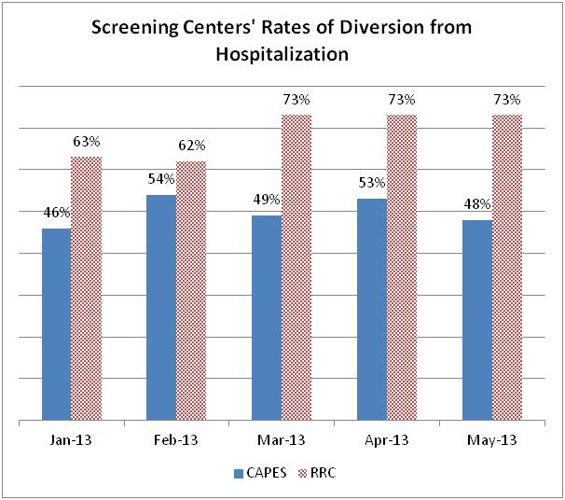
In compliance with Section III.C.1, the State launched the Recovery Response Center (RRC) in Ellendale about a year ago and it has been collecting data regarding its impact and utilization. As is presented in the chart below, in May, 2013, RRC diverted from hospitalization 73% of people evaluated. By way of comparison, the hospital-based CAPES program, which serves the northern part of the state and utilizes a more traditional model, diverted from hospitalization 48%% of the people assessed that month. The following chart presents a comparison of the diversion rates for these two screening centers during January through May of 2013. RRC estimates that substantial additional individuals can be diverted from hospital care if it had a capacity for voluntary overnight crisis stabilization.
When the walk-in center in Ellendale was being planned, there was a clear understanding of the need for such a program in the southern part of the state, but a much less precise understanding of what the demand for its services would be. RRC is already in the position where it routinely has to delay or deny transfers in from hospital emergency departments because it is at capacity. This information is being tracked by month, day, and time of day so needed adjustments in the program’s capacity can be designed accordingly. Furthermore, RRC is collecting data on individuals who are being referred elsewhere because their immediate need is for detox services. DSAMH is using this information as it moves forward with some major improvements in its substance use service network.

Recommendations:
- The State should carefully examine whether the capacities of RRC reflect the needs of the southern part of the Delaware in order to assure that there is ready access to its services and that individuals appropriate for transfer to RRC do not become backed up in emergency departments. Based on available data, it appears that a good case can be made for expanding the program’s capacities.
- Not only for purposes of complying with the Agreement (e.g., with regard to the hospital bed-day reductions discussed elsewhere), but also to improve cost efficiencies, the State should evaluate an expansion of the Ellendale program to include voluntary overnight crisis services.
- Given the demonstrated success of RRC in diverting high percentages of individuals assessed from hospital care, the State should develop a crisis walk-in center applying its model for New Castle County.

- Crisis Stabilization Services

Substantial Compliance.
Section III.D.2 of the Agreement requires that the State train all provider staff and law enforcement personnel regarding the use of crisis walk-in centers rather than IMDs or hospital emergency departments for individuals who are experiencing mental health crises. The State is in Substantial Compliance with this requirement; it is providing ongoing training to law enforcement, providers and other stakeholders statewide with regard to the use of crisis walk-in centers.

Not only is the RRC relatively new and its program model non-traditional, but as discussed above this walk-in center was launched in a part of the state that had lacked alternatives to hospital emergency departments and that had become accustomed to relying heavily on them. There is good reason to conclude that the RRC is having its intended impact. Beebe Medical Center, one of the major hospitals serving the southern part of the state, has reported a notable decrease in the number of psychiatric patients being seen in its emergency department.

Reduction in Inpatient Bed Days:
Section III.D.3 of the Agreement requires that by about one year from now—July 1, 2014—the State will need to reduce its publicly funded inpatient bed days by 30% of its baseline. While compliance with this provision is not yet required, this is a very important requirement because it reflects the State’s success in moving from an institutional model of services to one that promotes individuals with serious mental illness living successfully in integrated community settings. Achievement of this benchmark will represent the combined effects of a number of program and policy elements required by the Agreement, among them, screening and diversion activities by Mobile Crisis services, Crisis Walk-in Centers and House Bill 311; the impact of ACT, CRISP and ICM; availability of Crisis Apartments; and careful management of clinical services.
Furthermore, it reflects the State’s capacity to move from high-cost hospital care—the evaluation presented above in the section relating to the Use of Data references (albeit in very rough terms) the levels of savings that are potentially available—to more ADA compliance and less costly community services. Accordingly, the State and the Monitor have been carefully tracking trends in the use of bed days by the targeted population. Again, DSAMH’s evolving capacities for data analytics is proving invaluable in identifying progress and challenges in meeting this requirement.
For purposes of evaluation, the parties have agreed that the baseline to be used for measuring compliance with this provision will be the number of publicly funded bed days in DPC and the IMDs during the fiscal year preceding the effective date of the Agreement (June 30, 2010 to July 1, 2011). During that period, people with serious mental illness accounted for 62,931 bed-days. A 30% reduction from this baseline, to be achieved by next July, is 44,052 bed days. The 50% reduction to be achieved by July, 2016 is 31,465. As is presented in the chart below, the State has made some progress during the two years of implementing the Agreement (FY12 and FY13 in the chart), but this has resulted in only a 6% decrease thus far.

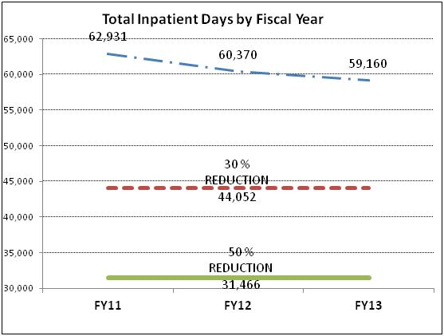
The following charts further demonstrate how DSAMH is using data analytics to evaluate its status with respect to this important benchmark and to target its interventions
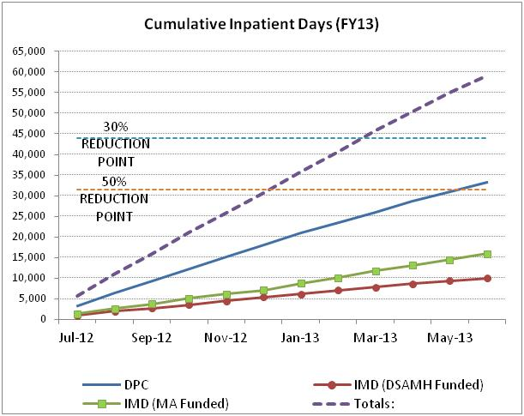
accordingly. The first chart shows a running total of accumulated bed-days during the past year and the relative contributions to the accumulated bed-days from DPC, from inpatient care in the IMDs that is controlled by Medicaid managed care (“MA Funded”), and from inpatient care in IMDs that is managed by DSAMH (“DSAMH Funded”). This analysis shows that around March of the year, the State had already reached its annual target (i.e., the line for Total days intersects the 30% reduction line around March). In the subsequent months, the State was exceeding targeted limit. The greatest contributor to bed-days was DPC—in part, because it includes some individuals with much longer term hospital stays—followed by Medicaid managed acute care clients and then DSAMH managed acute care clients.
The second chart clarifies where DSAMH has been successful in achieving reductions in bed-days and where there are challenges that need special focus. It tracks the total bed days utilized each month (as opposed to the month-to-month running total in the first chart) by provider type over the past three years. The dotted line with the Totals shows the monthly use of bed-days and the slight drop that has occurred over time. The DPC

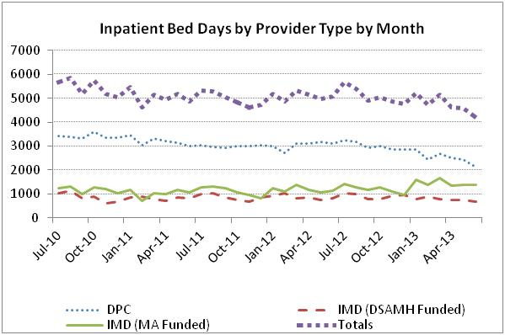

line shows that, primarily through community discharges from long-term care, there has actually been a significant decrease in monthly bed-days, from 3,426 in July of 2010 to around 2,131 in June of 2013; that is a 38% reduction. In fact, DPC was able to close a long term care unit, bringing its civil beds down from 120 to 80. The bed-days associated with DSAMH-funded care in the IMDs have remained relatively unchanged over time, with a slight reduction. But the monthly bed-days under Medicaid managed care have actually increased, from 1,228 in July of 2010 to 1,373 in June of 2013—a growth of 12%.
Based on these and other analyses, as well as the urging of DOJ, DSAMH has undertaken several measures to meet the challenging targets for bed-use reduction. These include the initiation of on-site utilization review by DSAMH for the individuals it funds within the IMDs. DSAMH is receiving ongoing consultation by an expert contracted through the Monitor to maximize the effectiveness of this new initiative. As is referenced in an earlier section of this report, navigating the complicated interface with Medicaid managed care is complicated for a number of technical reasons. The Director of DMMA is fully—and positively—engaged in crafting a plan to help move the State to compliance with this provision, and to do so in ways that maximize efficiencies and outcomes that are consistent with the ADA.
Finally, it is worth reiterating that, though it may be difficult for the State to meet this impending benchmark, its improving capacities to access and analyze data put it in a wholly different position from prior years. The multiple charts are included in this report to demonstrate how DSAMH is now able to evaluate performance and to target remedies accordingly. The evaluation of individuals discharged from DPC (presented above) demonstrates that a population that had accounted for very high numbers of hospital bed-days can be successfully discharged with ACT, supported housing and other evidence-based community services. Further referrals from DPC and the IMDs with the levels of intensive support available through ACT, ICM and CRISP may result in additional reductions and present a similarly positive return on an investment in integrating community services.
Recommendations:
The recommendations (discussed elsewhere in this report) relating to the expansion in the number of ACT teams, the development of an RRC-style Crisis Walk-in Center to serve the northern part of the state, and reforms in how clinical services are managed are essential for fulfilling this important requirement.

- Crisis Apartments

Substantial Compliance.
Section III.E.2 of the Agreement requires the state to make 2 additional crisis apartments available by July1, 2013, bringing the total number of crisis apartments to 4. These apartments are required to be situated so that individuals throughout the state in need of this service can have access. The State has surpassed this requirement. There are now 9 crisis apartments situated throughout the state. DSAMH is monitoring their occupancy patterns and is taking measures to ensure that Mobile Crisis Teams and other providers are aware of the availability of beds. The typical length of stay in these crisis beds is about three to seven days.

- Assertive Community Treatment

Substantial Compliance.
Section III.F.2 requires that the State establish 1 additional ACT team—bringing the total to 9 ACT teams—by September 1, 2013. The State has already surpassed that target. There are presently 11 ACT teams statewide. Nevertheless, there are now waiting lists of individuals in need of ACT services in New Castle County because the teams there are largely at capacity.
DSAMH is routinely assessing the fidelity of all 11 teams with the TMAC model, which the parties have agreed to as a more recovery-oriented standard than the Dartmouth model referenced in the Agreement. The teams are in various stages of development and are receiving consultation and support, as needed, from DSAMH. During the past year, one of the ACT providers discontinued services in the state, but DSAMH engaged alternate providers without significant or sustained interruptions in services.
The Monitor recently had an opportunity to meet with a Sussex County ACT Team, which was specifically selected because the southern part of the state has historically been underserved. Individually and collectively the members of the team were impressive in their knowledge of the status and needs of the individuals being served, their focus on how individuals were navigating the various day-to-day demands of community living, and their consideration of medication-related issues without allowing these to become the dominant interest. One telltale quality of a well-functioning ACT team was very much in evidence: The Monitor entered the team’s meeting while it was already underway and, to avoid being disruptive, introductions of various members were made after the fact. During the discussions taking place prior to these introductions, it was very difficult to discern who was the doctor, the nurse, the case manager, the peer specialist, and so on. All were very active participants and there was clearly an interest in what every member had to contribute. Each member appeared to have a working knowledge of not only the individual’s clinical needs, but what was going on in that individual’s life. This small observation is an important measure of a good ACT team, where professional roles (and associated hierarchies) are intended to be blurred and where there is a collaborative effort to assist the individual in meeting his or her needs..
On a more global level, DSAMH has data that demonstrate the effectiveness of the ACT model and other community programs. The chart below shows that individuals being served by ACT, Intensive Care Management (discussed in the next section) and CRISP account for very few involuntary hospitalizations. This occurs even though these programs serve individuals who have significant disabilities, generally with long histories of recurrent hospital admissions. In contrast, the great majority of hospital admissions involve individuals who are new to the system or those being served by private practitioners, many of whom are being served through MCO care management—a population that tends to be higher functioning.
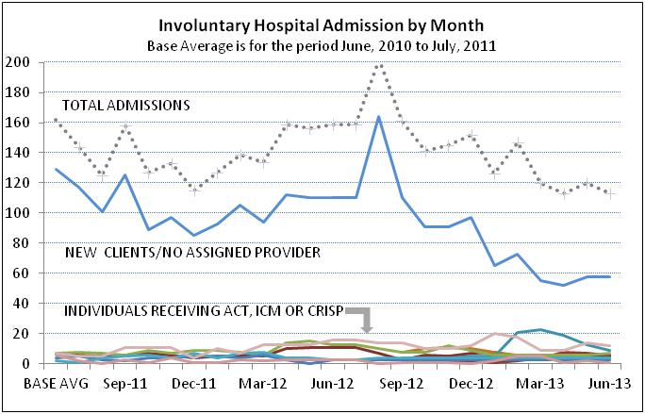

These data, as well as the individuals’ stories presented below in regard to supported housing and employment, affirm that the State’s ACT programs are serving an essential role in achieving the requirements of the Agreement.
Recommendations:
Based on the waiting list for ACT in New Castle County, as well as the effectiveness of the State’s ACT programs in assisting individuals who have significant needs and who have required high-end, high-cost services, the Monitor has recommended that the State further expand the number of ACT teams by two. The ACT teams (and CRISP) have been pivotal in reducing the long-term care population at DPC; this population (which accounts for considerable inpatient bed-days), can further reduced with additional ACT capacity.
In addition, through exchanges with DSAMH, as well as stakeholders in the corrections and judicial systems, it is clear that there is a need for ACT services among people with serious mental illness who have become caught up in the criminal justice system. Finally, as has been discussed in prior reports, individuals with serious mental illness and co-occurring substance use problems require specialized services, and ACT can be effective in reducing their frequent use of emergency services and psychiatric inpatient beds. For all of the above reasons, the State should work to further expand the number of ACT teams.

- Intensive Care Management

Substantial Compliance.
Section III.G.2 of the Agreement required the State to have a total of 4 Intensive Care Management (“ICM”) teams operational by January 1, 2013. As was described in the last report, Delaware has surpassed this target, having 5 ICM teams operational statewide. These teams are currently serving 590 individuals, an increase of 18% over what was reported six months ago. As was discussed in the previous section with reference to ACT, individuals receiving ICM services are, by definition, at elevated risk of mental health crises, including rehospitalization. Nevertheless, they do not account for a significant proportion of psychiatric hospital admissions.

- Case Management

Substantial Compliance.
Section III.H.2 requires that by September 1, 2013, the State will train and begin to utilize 3 additional care managers—termed Targeted Care Managers (“TCM”) within the DSAMH system--bringing the total to 18. The State has already met and surpassed this target, having 21 TCMs working in the community and, increasingly, participating in discharge planning at DPC and the IMDs. DSAMH’s longer-range plan is to utilize TCMs as a part of the “front door” for individuals entering public mental health services, with their involvement continuing as needed by the individual.

- Supported Housing
Substantial Compliance.
Section III.I.3 requires the State to increase housing vouchers, subsidies and bridge funding so that 450 individuals are served as of July 1, 2013. The State continues to do an exemplary job in responding to this provision. The chart below presents data demonstrating that the State is surpassing its target. During the past year, it has created new integrated supported housing for 221 individuals. Of these individuals, 186 received housing supports through state funded programs (SRAP or CRISP). The total number of individuals receiving supported housing in integrated settings (or in semi-integrated supervised apartments, in the case of the 150 individuals who were grandfathered in under the Agreement) is 522. In other words, the State is well on its way to achieving its target for July 1, 2014 of 550 individuals.

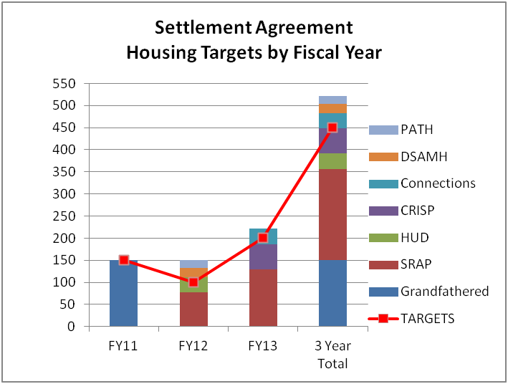
Delaware’s success in its supported housing program goes well beyond its achievement of the numerical targets of the Agreement. Access to integrated housing with needed supports is fundamental to the ADA’s vision of eliminating the social and institutional segregation that have been common among people with serious mental illness.

The Monitor recently had an opportunity to meet William and Steve, who are served by the Sussex County ACT team and have chosen to share an apartment together. Again, it is worth noting that this area of the State has traditionally been underserved, and thus the availability of ACT and supported housing in the southern counties is an important measure of success. William has a serious mental illness and a history of involvement with the criminal justice system. Steve also has a serious mental illness, in addition to a co-occurring problem with alcohol abuse. He has been in the criminal justice system and has been homeless, sometimes sleeping in shelters.
Both William and Steve have disabilities and histories that in the past would have made it very likely that they would be relegated to institutions. These individuals now live in a pleasant, modern—and, in keeping with the vision of the ADA—ordinary apartment complex. They are visited by members of their ACT team 2-3 times per week. They have their own bedrooms and share responsibilities in relation to cooking and shopping.
William and Steve are not yet at their point in recovery where they are fully engaged in outside social activities or employment, but they are doing well living quietly in their own home. Given their histories, that, in itself, is an enormous accomplishment. But there is more to this story that is telling about their success and the success of this DSAMH initiative. Several months back, Steve’s prior roommate left and he was having some problems managing things. Not only was he receiving support from his ACT team, but reportedly neighbors looked in on him to encourage him and ensure that he was doing okay. That interaction with neighbors is mundane, and it is also a testament to how longstanding social barriers affecting people with serious mental illness are beginning to break down.

- Supported Employment

Substantial Compliance.
Section III.J.2 of the Agreement requires the state to provide supported employment services to an addition 300 individuals, bringing the total to 400 individuals. There are several levels of employment services provided through the State’s Department of Vocational Rehabilitation (“DVR”). For purposes of evaluating compliance with this provision, supported employment services to individuals with serious and persistent mental illness were counted if an individual had progressed through the DVR system to the point that there was an active plan for vocational rehabilitation or, of course, if the individual was being employed at some level and receiving needed supports. During the past year, a total of 569 individuals met these criteria, thus surpassing the Agreement’s requirements. Of this group, 67 were actively employed at some point during the year.
Individuals who are a part of the population targeted by the Agreement commonly have unstable work histories—if they have work histories at all—and their entry into the workforce may be challenged by their levels of impairment, criminal justice histories, and where they stand with respect to their individual recoveries. A substantial number of the individuals receiving supported employment services (99) had a substance abuse issue co-occurring with serious mental illness, presenting an additional set of challenges to employment.
Individuals with SPMI who have obtained gainful employment are carrying out critical functions as peer counselors who are employed by the State or by providers (Peer services are discussed below). Others work in mainstream work environments with needed supports. The stories below describe some of the individuals who are beneficiaries of the State’s employment initiatives and the range of their work.

Jayne lives in her own home with her husband and daughter. She has a long history of treatment for bipolar disorder with psychotic features and has been hospitalized several times. She works as a research assistant for the State, in part, in conjunction with the University of Pennsylvania which is evaluating DSAMH’s CRISP program. In that capacity, she is being certified in human subject research, following the protocol that the university uses for all such research assistants. She sees this as an important addition to her resume. Her CRISP research focuses on consumers’ experiences in that program. In addition, Jayne carries out peer satisfaction interviews as a part of DSAMH’s quality assurance program. In both instances, she has leant her first-hand experience as a consumer to assist in the design of the questionnaires being utilized. She finds her work highly rewarding, indicating that “these studies will improve people’s lives in the community.”

Sandra has been in and out of psychiatric hospitals due to schizophrenia and bipolar disorder. She is served by an ACT team that supports her in living in her own apartment. Sandra describes her life as having been “out of control,” but now works in mainstream employment in a variety of tasks, including assembly work. She reports “I’ve been able to stay out of the hospital for a long time now...and I’m able to go to work.” She regards her current work as transitional, noting “I’m not where I want to be, but I’m not where I was.”

Todd is a middle-aged man who has hospitalized multiple times for treatment of schizophrenia. For about a year, he has been working in food services at the University of Delaware. He reports that he is often complimented about his work and he takes great pride in leading a productive life. “I am treated like everybody else,” he says, which is an apt description of what the Agreement—and the ADA—intend to achieve for people with disabilities.

Recommendation:

- Each of the providers with ACT teams has been able to fund one employment specialist for the agency. DSAMH’s plan has been to focus on bringing these new ACT teams into fidelity with the TMAC model and, as the basic structure and operations become established (which they now are), to ramp up their capacities for supported employment by having one dedicated employment counselor for each team. This is a sensible approach. It is recommended that these positions be established this year.
- DSAMH also plans to create a new leadership position within the Division to coordinate employment services throughout its programs. This is a very worthwhile measure and should help the State achieve the significant increases in the number of individuals receiving supported employment services that are required per the Agreement in the coming years.

- Rehabilitation Services
Substantial Compliance.
Section III.K.2 of the Agreement requires the State to provide rehabilitation services to an additional 500 individuals by July 1, 2013, bringing the total requirement to 600. Rehabilitation services comprise an array of activities, such as education, substance abuse treatment, and recreational activities. Some of these components are not well defined in the State’s data systems. Furthermore, without sufficient intensity of a rehabilitative service, the meaning is dubious (for instance, crediting a single recreational encounter with an individual towards the goal of 600). For purposes of evaluating the State’s compliance with this provision, an individual was counted if:
- Psychosocial Rehabilitative Services, Psychosocial Group Services, or Family Psychosocial Education was provided at least twice per month for at least 6 months. 439 individuals met this criterion;
- Some level of substance abuse service for a co-occurring disorder was provided during the year. 929 individuals met this criterion; or
- There was ongoing participation as a peer volunteer. 10 individuals met this criterion.
The State is surpassing its requirements with respect to Rehabilitation Services.

- Family and Peer Supports
Substantial Compliance.
Section III.L.2 of the Agreement requires the State to provide family or peer supports to an additional 250 individuals, bringing the total number receiving this service to 500. As has been noted in previous reports, an impressive peer movement has evolved in the State, whereby individuals who, themselves, have mental illness provide vital services to members of the population covered by the Agreement. These services range from supports to inpatient at DPC (where peers meet with individuals and provide “Hope” bags containing information and essentials upon admission and discharge), to socialization and support in consumer advocacy, to participation on ACT teams. The State has surpassed its requirements with respect to this provision, providing Family and Peer Supports to approximately 600 individuals.

- Transition Planning
Substantial Compliance.
Section IV.A sets forth requirements for person-centered recovery-oriented discharge planning, including the requirement that individuals be assessed from the perspective that, with sufficient supports and services, they can live in integrated community settings. Fulfillment of this provision requires not only procedural changes, but significant changes in how the needs of individuals are conceptualized and how their preferences are accommodated.
Delaware continues to make important advances in achieving these reforms. For example, the person-centered Community Living Questionnaire that was developed at DPC to meet these requirements is now being used in the IMDs, as well, with collaboration by community providers. Furthermore, DSAMH continues to require special review of individuals who (generally for physical healthcare reasons) are not being recommended for fully integrated housing upon discharge. In these small number of instances—perhaps a dozen during the course of the past year—the hospital or community provider compiles a detailed analysis explaining why a fully integrated living arrangement is not feasible. These analyses are then reviewed by DSAMH and by the Monitor, sometimes culminating in a time-limited approval for an alternative setting while physical healthcare issues stabilize. This system is working well.

IV. Summary
Delaware continues to make significant progress toward fulfillment of its obligations under the Agreement. As is delineated above, it has met or surpassed the benchmarks contained in the Agreement for each of the measures that have come due. The State continues to move forward on measures to address the structural issues—data, involvement of the court system, and care management—that are necessary for it to sustain its accomplishments through the duration of the Agreement and beyond. The leadership in the State, at DHSS, and DSAMH merit praise for their efforts to advance the opportunities for Delawareans with SPMI and other disabilities.

Robert Bernstein, Ph.D.
Court Monitor

The median is the number of days of continuous inpatient care received by half of this group. The divergence of the mean (i.e., the average) days of care and the median days of care reflects the inclusion of some individuals who had extremely long durations of hospitalization.
American Psychiatric Association. (2000). Diagnostic and statistical manual of mental disorders (4th ed., text rev.) (p.34). Washington, DC: Author.
In a one-tail t-Test, t=-0.926, P=0.178, ns.
Readmission rates are calculated as a percentage of the 105 individuals who were discharged from DPC in fiscal year 2013 following 60+ days of hospital care and who were re-hospitalized for psychiatric care.
U.S. Department of Health and Human Services, Substance Abuse and Mental Health Services Administration, National Outcomes Measures, 2011.
For example, in some states outpatient commitment is regarded as a means of jumping the queue and reducing time on a waiting list of services.

